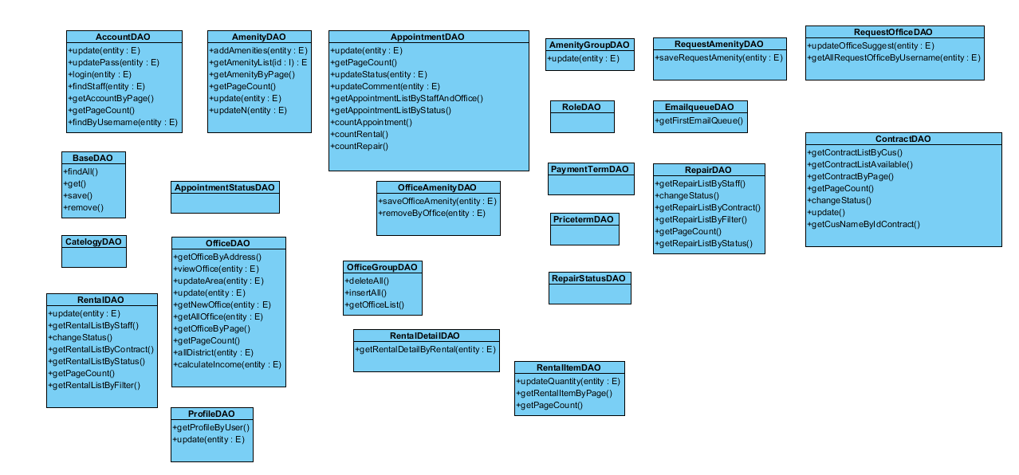

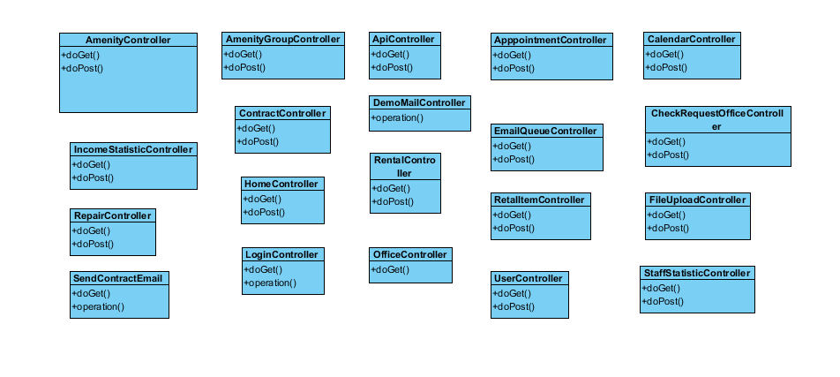

#### Class Diagram Explanation

##### Class AccountDAO

Attribute

|  |  |  |  |
| --- | --- | --- | --- |
| **Attribute** | **Type** | **Visibility** | **Description** |
| email | String | private | Email of account |
| password | String | private | Password to login into system |
| username | int | private | Username to login into system |
| newAccount | Account | private | The class of account follow username |
| pass | String | private | Password to login into system |
| firstResult | int | private |  |
| pageSize | int | private |  |

Method

|  |  |  |  |
| --- | --- | --- | --- |
| **Attribute** | **Type** | **Visibility** | **Description** |
| update() | void | public | Update all information of exist account. |
| updatePass() | boolean | public | Update password of exist account |
| delete() | boolen | public | Delete an exist account |
| login() | Account | public | Login into system with exist account |
| findStaff() | List<Account> | public | List array of staff account |
| getAccountByPage() | List<Account> | public | Get a list of account |
| getPageCount() | int | public | Count number of page |

##### Class AmenityDAO

Attribute

|  |  |  |  |
| --- | --- | --- | --- |
| **Attribute** | **Type** | **Visibility** | **Description** |
| amenity | String | private | Name of amenity |
| amenity<List> | List<String> | private | The list of amenity |
| firstResult | int | private |  |
| pageSize | int | private |  |
| name | String | private | Name of account |
| newAmenity | Amenity | private | The class contain the instance of the amenity |
| id | int | private | Unique ID of each amenity |
| description | String | private | Description of each amenity |
| weight | int | private | Weight of each amenity |
| amenityGroupId | int | private | ID of group that amenity belong to |
| priority | int | private | Priority of each amenity |

Method

|  |  |  |  |
| --- | --- | --- | --- |
| **Attribute** | **Type** | **Visibility** | **Description** |
| addAmenities() | boolean | public | Add amenity into database |
| getAmenityList() | List<Amenity> | public | Get a list of amenity |
| getPageCount() | int | public | Count number of page |
| update() | Boolean | public | Update amenity information |
| updateN() | Boolean | public | Update amenity information |
| getAmenityByPage() | List<Amenity> | public | Get a list of amenity |

##### Class AmenityGroupDAO

Attribute

|  |  |  |  |
| --- | --- | --- | --- |
| **Attribute** | **Type** | **Visibility** | **Description** |
| name | String | private | Name of amenity group |
| amenityGroup | AmenityGroup | private | The class contain the instance of the amenity group |
|  |  |  |  |

Method

|  |  |  |  |
| --- | --- | --- | --- |
| **Attribute** | **Type** | **Visibility** | **Description** |
| update() | boolean | public | update amenity group information |

##### Class AppointmentDAO

Attribute

|  |  |  |  |
| --- | --- | --- | --- |
| **Attribute** | **Type** | **Visibility** | **Description** |
| id | int | private | Unique ID of each appointment |
| assignedStaff | String | private | Name of staff has been assigned in to appointment |
| time | Date | private | Time to meet customer |
| statusId | int | private | Id of current status of appointment |
| firstResult | int | private |  |
| pageSize | int | private |  |
| comment | String | private | Comment of customer about appointment |
| username | String | private | Name of customer who rent office |
| officeName | String | private | Name of office |
| status | int | private | Current status of appointment |

Method

|  |  |  |  |
| --- | --- | --- | --- |
| **Attribute** | **Type** | **Visibility** | **Description** |
| countAppointment() | int | public | count number of appointment |
| getAppointmentListByStatus() | List<Appointment> | public | Get appointment list which available in current time |
| getPageCount() | int | public | Get number of page |
| update() | void | public | Update information of appointment |
| updateStatus() | Boolean | public | Update status of appointment |
| updateComment() | Boolean | public | Update comment of appointment |
| getAppointmentListByStaffAndOffice  () | List<Appointment> | public | Get appointment list follow staff and office |
| countRental() | int | public | Count number of rental |
| countRepair() | int | public | Coun number of repair |

##### Class ContractDAO

Attribute

|  |  |  |  |
| --- | --- | --- | --- |
| **Attribute** | **Type** | **Visibility** | **Description** |
| username | String | private | Name of customer who this contract belong to |
| firstResult | int | private |  |
| pageSize | int | private |  |
| id | int | private | Unique ID of each contract |
| status | int | private | Status of each contract |
| customerUsername | String | private | Name of customer who this contract belong to |
| officeId | int | private | Unique ID of each office |
| startDate | Date | private | The start date of the week for the schedule |
| endDate | Date | private | The end date of the week for the schedule |
| paymentFee | int | private | The fee payment of contract |
| paymentTerm | int | private | The term payment of contract |
| statusId | int | private | Unique ID of each contract status |

Method

|  |  |  |  |
| --- | --- | --- | --- |
| **Attribute** | **Type** | **Visibility** | **Description** |
| getContractListByCus() | List<Contract> | public | Get list of contract follow name of customer |
| getContractListAvailable() | List<Contract> | public | Get list of contract follow status |
| getContractByPage() | int | public | Get list of contract |
| getPageCount() | int | public | Get number of page |
| changeStatus() | boolean | public | Change status of contract |
| update() | void | public | Update information of contract |
| getCusNameByIdContract() | Object | public | Get name of customer follow contract |

##### Class OfficeAmenityDAO

Attribute

|  |  |  |  |
| --- | --- | --- | --- |
| **Attribute** | **Type** | **Visibility** | **Description** |
| officeId | int | private | Unique ID of each office |
| amenityList | List<Integer> | private | List of amenity |
| id | int | private | Unique ID of each office amenity |

Method

|  |  |  |  |
| --- | --- | --- | --- |
| **Attribute** | **Type** | **Visibility** | **Description** |
| saveOfficeAmenity() | boolean | public | Add new amenity into office |
| removeByOffice() | boolean | public | delete amenity in office |

##### Class OfficeDAO

Attribute

|  |  |  |  |
| --- | --- | --- | --- |
| **Attribute** | **Type** | **Visibility** | **Description** |
| searchKey | String | private | keyword to search |
| id | int | private | Unique ID of each office |
| area | Double | private | Number of arena that office have |
| newOffice | Office | private | The class of office |
| firstResult | int | private |  |
| pageSize | int | private |  |
| startDate | Date | private | The start date of the week for the schedule |
| endDate | Date | private | The end date of the week for the schedule |
| district | String | private | Information about district of office |

Method

|  |  |  |  |
| --- | --- | --- | --- |
| **Attribute** | **Type** | **Visibility** | **Description** |
| getOfficeByAddress() | List<Office> | public | Get list of office by address |
| viewOffice() | Office | public | Get information about office and give to view |
| updateArea() | boolean | public | Update information of area |
| update() | boolean | public | update information of office |
| getNewOffice() | List<Office> | public | Get 5 office have the largest of number of view |
| getAllOffice() | List<Office> | public | Get a list of office |
| getOfficeByPage() | List<Office> | public | Get a list of office |

##### Class OfficeGroupDAO

Attribute

|  |  |  |  |
| --- | --- | --- | --- |
| **Attribute** | **Type** | **Visibility** | **Description** |
| group | int [][] | private |  |
| group | int | private |  |

Method

|  |  |  |  |
| --- | --- | --- | --- |
| **Attribute** | **Type** | **Visibility** | **Description** |
| deleteAll() | int | public |  |
| insertAll() | boolean | public |  |
| getOfficeList() | List<OfficeGroup> | public |  |

##### Class ProfileDAO

Attribute

|  |  |  |  |
| --- | --- | --- | --- |
| **Attribute** | **Type** | **Visibility** | **Description** |
| username | String | private | Username to login into system |
| fullName | String | private | Fullname of customer |
| company | String | private | Name of company of customer |
| phone | String | private | Number phone of customer |
| address | String | private | Address of customer |
| birthday | Timestamp | private | birthday of customer |

Method

|  |  |  |  |
| --- | --- | --- | --- |
| **Attribute** | **Type** | **Visibility** | **Description** |
| getProfileByUser() | Object | public | Get information of profile by name of user |
| update() | boolean | public | Update profile of user |

##### Class RentalDAO

Attribute

|  |  |  |  |
| --- | --- | --- | --- |
| **Attribute** | **Type** | **Visibility** | **Description** |
| id | int | private | Unique ID of each rental |
| contractId | int | private | Unique ID of each contract |
| assignStaff | String | private | Name of staff to assign |
| statusId | int | private | Unique ID of each rental status |
| description | String | private | Description about rental |
| assignedTime | Date | private | Time which assign staff |
| firstResult | int | private |  |
| pageSize | int | private |  |
| status | int | private | Current status of rental |
| officeName | String | private | Name of office |
| staff | String | private | Name of staff |

Method

|  |  |  |  |
| --- | --- | --- | --- |
| **Attribute** | **Type** | **Visibility** | **Description** |
| update() | void | public | Update information if rental |
| getRentalListByStaff() | List<Rental> | public | Get a list of rental by staff name |
| changeStatus() | boolean | public | Change status of rental |
| getRentalListByContract() | List<Rental> | public | Get a list of rental by contract |
| getRentalListByStatus() | List<Rental> | public | Get a list of rental by status |
| getPageCount() | int | public | Get number of page |
| getRentalListByFilter() | List<Rental> | public | Get a list of rental by information in filter |

##### Class RentalDetailDAO

Attribute

|  |  |  |  |
| --- | --- | --- | --- |
| **Attribute** | **Type** | **Visibility** | **Description** |
| rentalId | int | private | Unique ID of each rental |

Method

|  |  |  |  |
| --- | --- | --- | --- |
| Attribute | Type | Visibility | Description |
| getRentalDetailByRental() | List<RentalDetail> | public | Get a list of rental detail by rental name |

##### Class RentalItemDAO

Attribute

|  |  |  |  |
| --- | --- | --- | --- |
| **Attribute** | **Type** | **Visibility** | **Description** |
| id | int | private | Unique ID of each rental item |
| name | String | private | Name of rental item |
| description | String | private | Description of rental item |
| price | double | private | Price of of rental item |
| quantity | int | private | Quantity of rental item |
| imageUrl | String | private | Image of of rental item |
| firstResult | int | private |  |
| pageSize | int | private |  |

Method

|  |  |  |  |
| --- | --- | --- | --- |
| Attribute | Type | Visibility | Description |
| update() | void | public | Update information of rental item |
| updateQuantity() | void | public | Update quantity of rental item |
| getRentalItemByPage() | List<RentalItem> | public | Get a list of rental item |
| getPageCount() | int | public | Get number of page |

##### Class RepairDAO

Attribute

|  |  |  |  |
| --- | --- | --- | --- |
| **Attribute** | **Type** | **Visibility** | **Description** |
| id | int | private | Unique ID of each repair |
| contractId | int | private | Unique ID of each contract |
| assignedStaff | String | private | Name of staff has been assigned |
| description | double | private | Description of repair |
| assignedTime | Date | private | Assigned time of repair |
| repairStatusId | int | private | Unique ID of each repair status |
| username | String | private |  |
| status | int | private |  |
| startDate | Date | private | The start date of the week for the schedule |
| endDate | Date | private | The end date of the week for the schedule |
| firstResult | int | private |  |
| pageSize | int | private |  |
| officeId | int | private | Unique ID of each office |
| officeName | String | private | Name of office |
| staff | String | private | Name of staff |

Method

|  |  |  |  |
| --- | --- | --- | --- |
| Attribute | Type | Visibility | Description |
| update() | void | public | Update information of repair |
| getRepairListByStaff() | List<Repair> | public | Get a list of repair by staff |
| changeStatus() | boolean | public | Change status of repair |
| getRepairListByContract() | List<Repair> | public | Get a list of repair by contract |
| getRepairListByFilter() | List<Repair> | public | Get a list of repair by information in filter |
| getRepairListByFilter() | List<Repair> | public | Get a list of repair by information in filter |
| getPageCount() | int | public | Get number of page |
| getRepairListByStatus() | List<Repair> | public | Get a list of repair by current status of repair |

##### Class RepairDetailDAO

Attribute

|  |  |  |  |
| --- | --- | --- | --- |
| **Attribute** | **Type** | **Visibility** | **Description** |
| repairId | int | private | Unique ID of each repair |
| amenityList | List<Integer> | private | The list of amenity which repair belong to |

Method

|  |  |  |  |
| --- | --- | --- | --- |
| **Attribute** | **Type** | **Visibility** | **Description** |
| saveRepairDetail() | boolean | public | Save information of repair detail |

##### Class RequestAmenityDAO

Attribute

|  |  |  |  |
| --- | --- | --- | --- |
| **Attribute** | **Type** | **Visibility** | **Description** |
| requestOfficeId | int | private | Unique ID of each request office |
| amenityList | List<Integer> | private | The list of amenity which request belong to |

Method

|  |  |  |  |
| --- | --- | --- | --- |
| **Attribute** | **Type** | **Visibility** | **Description** |
| saveRequestAmenity() | boolean | public | Save information of request amenity |

##### Class RequestOfficeDAO

Attribute

|  |  |  |  |
| --- | --- | --- | --- |
| **Attribute** | **Type** | **Visibility** | **Description** |
| id | int | private | Unique ID of each request request office |
| officeSuggest | String | private | Name of office which suitable with request of customer |
| username | String | private | Name of customer |

Method

|  |  |  |  |
| --- | --- | --- | --- |
| **Attribute** | **Type** | **Visibility** | **Description** |
| updateOfficeSuggest() | boolean | public | Update information of office suggest |
| getAllRequestOfficeByUsername() | List<RequestOffice> | public | Get a list off request office by username |

##### Class AppointmentStatusDAO

This is the presentation view of AppointmentController

##### Class CategoryDAO

This is the presentation view of OfficeController

##### Class PaymentTermDAO

This is the presentation view of OfficeController

##### Class PriceTermDAO

This is the presentation view of OfficeController

##### Class RepairStatusDAO

This is the presentation view of RepairController

##### Class RoleDAO

This is the presentation view of UserController